Quiz 3 questions

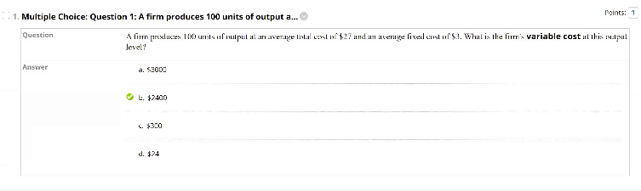

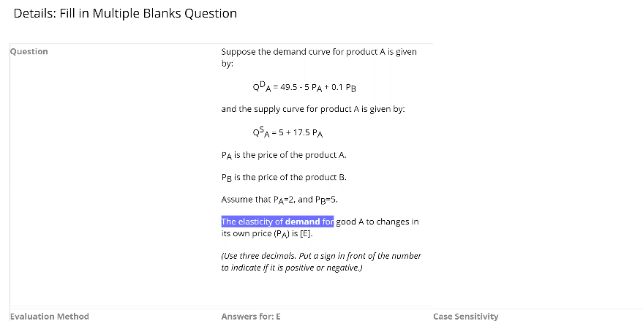

Chapter 15: Outline

* Monopoly
  + Monopoly: Market with only one seller
  + Monopsony: Market with only one buyer
* Reasons for Monopoly
  + Entry Blocked by Government Action
    - *Patents and copyrights*
    - *Public franchises*
  + Control of a Key Resource
  + Network Externalities
  + Natural Monopoly
* Profit Maximization for Monopoly
  + A Rule of Thumb for Monopoly Pricing
  + 
  + *Producing one extra unit and selling it at price P brings in revenue (1)(P) = P.*
  + *But because the firm faces a downward-sloping demand curve, producing and selling this extra unit also results in a small drop in price ΔP/ΔQ, which reduces the revenue from all units sold (i.e., a change in revenue Q[ΔP/ΔQ]).*
  + Text, letter

    Description automatically generated
  + A picture containing diagram

    Description automatically generated
* Monopoly Power
  + Measure of monopoly power calculated as excess of price over marginal cost as a fraction of price.
  + A picture containing text, sky

    Description automatically generated
* The Social Costs of Monopoly Power
* Public Policy towards Monopolies
  + Increasing competition with antitrust laws
  + *Based on antitrust laws, the Department of Justice (DOJ) or the Federal Trade Commission (FTC) can challenge mergers, break up monopolies, fine for anticompetitive behavior.*
  + Regulation
  + Anticompetitive Practices
    - Explicit agreement among producers to restrict output and /or fix price above competitive level
    - Implicit collusion:
    - ***parallel conduct***
    - *Form of implicit collusion in which one firm consistently follows actions of another.*
    - ***predatory pricing***
    - *Practice of pricing to drive current competitors out of business and to discourage new entrants in a market so that a firm can enjoy higher future profits.*
* Limiting Market Power: The Antitrust Laws



